

# Teacher of Classics Part-Time 0.7-0.9

**Required for September 2025**

We are looking to appoint a dynamic and inspirational teacher of Classics with excellent communication and interpersonal skills to teach Latin through the Senior School, Classical Civilisation at A level as well as contribute to the co-curricular life of the Classics department in this excellent and high performing school.

The successful candidate will be motivated and aspirational and will work with the department in promoting a love of the Classics both inside and outside the classroom. Applications are equally welcome from newly qualified teachers (for whom statutory induction would be provided) or from more experienced applicants.

A willingness to contribute to the wider life of the School beyond the classroom is also a requirement.

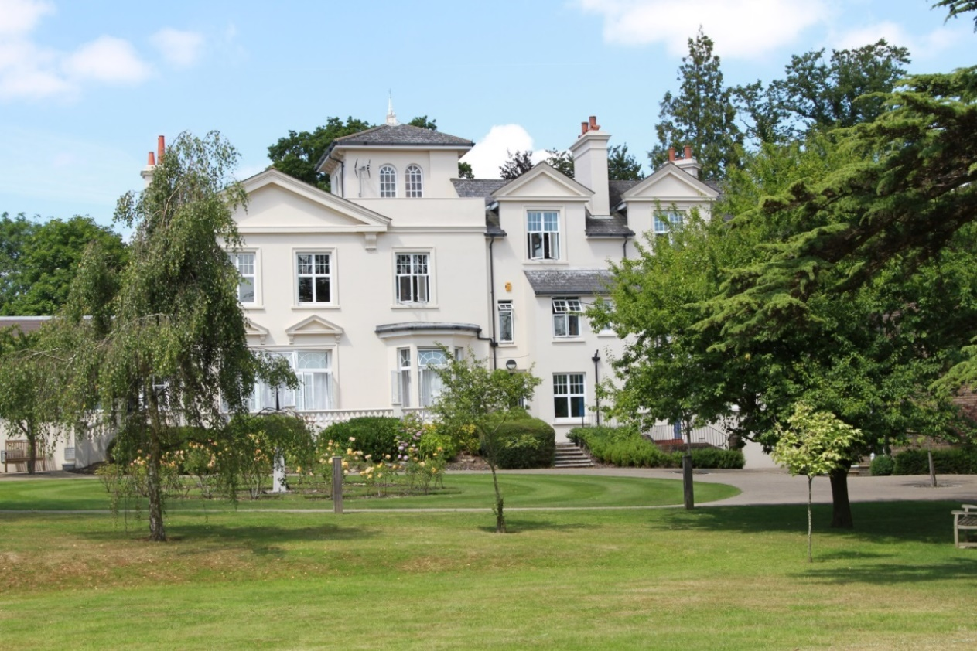

**ABOUT THE SCHOOL**

**Location**

The school is situated in a very pleasant thirteen-acre site in the conservation area of the town. Burgess Hill is a medium-sized town with its own theatre, orchestra, cinema and leisure centre. Burgess Hill is approximately ten miles from Brighton and Lewes, fifteen miles from Crawley and fifty miles from the centre of London. It is well served with fast roads – the M23 and M25. The school is a three minute walk from the railway station.

**Facilities**

The school is a blend of Victorian buildings and ultra-modern facilities and there has been a steady development of the facilities.

**Curriculum**

The school offers a full range of GCSE and A level courses in preparation for university entrance.

**Pastoral care**

Our pastoral system is designed to encourage and support the development of each individual student from the moment they arrive in school until the time they leave. We want to provide each student with the skills and confidence to help them to make the most of their time with us, at university and beyond. Implicit in the School aims is the expectation that every teacher will accept responsibility for the development in each pupil not only of the highest academic standards, but also of the confidence and self-esteem, which comes from being valued as an individual within a community.

**Co-curricular activities**

We believe that education is about giving young people the chance to be successful in as wide a range of areas as possible, and to feel a sense of pride in their achievements. Co-curricular activities give each student wonderful opportunities to explore their own talents and develop their individual skills to their full potential. The successful applicant will be expected to work effectively as part of the teaching team and play a full part in the wide range of co-curricular activities with which the school is involved. They will be encouraged to draw on their own interests and expertise to assist in continuing to promote a positive image of Classics throughout the school.

**CLASSICS DEPARTMENT**

The Classics Department comprises a full-time Head of Department and a part-time languages teacher. Latin and Classical Civilisation are taught at A level and Latin is taught throughout the Senior School. Classical Greek is also offered as a co-curricular activity. Results in public examinations are excellent and the department has produced successful Oxbridge candidates for the past three years.

Visits to the theatre, museums and lectures are arranged when possible. In previous years there have been trips to Rome, Sorrento and to the sites of Classical Greece and Roman Britain. We take an annual trip to the British Museum.

The following are currently taught:

**Years 7 and 8**

2 lessons per week

**Latin** - using Cambridge Latin Course, Book I.

**Year 9 - 11**

4 lessons per week

**Latin** – Book II and Latin to GCSE 1&2 then **Latin** OCR (Literature and Culture and Verse Literature).

**A level**

8 lessons per week in Lower Sixth and 8 lessons per week in Upper Sixth.

**Classical Civilisation** OCR. The modules studied include World of a Hero, Greek Theatre

and Politics of the Late Republic.

**Latin** OCR. The modules include Language and Verse and Prose set texts (currently Cicero,

Virgil, Apuleius and Ovid).

Latin is an increasingly popular subject at GCSE, with 11 students in Year 11, 12 in Year 10 and 15 in Year 9. The department also offers Intermediate Greek certificate taught as an after-school club.

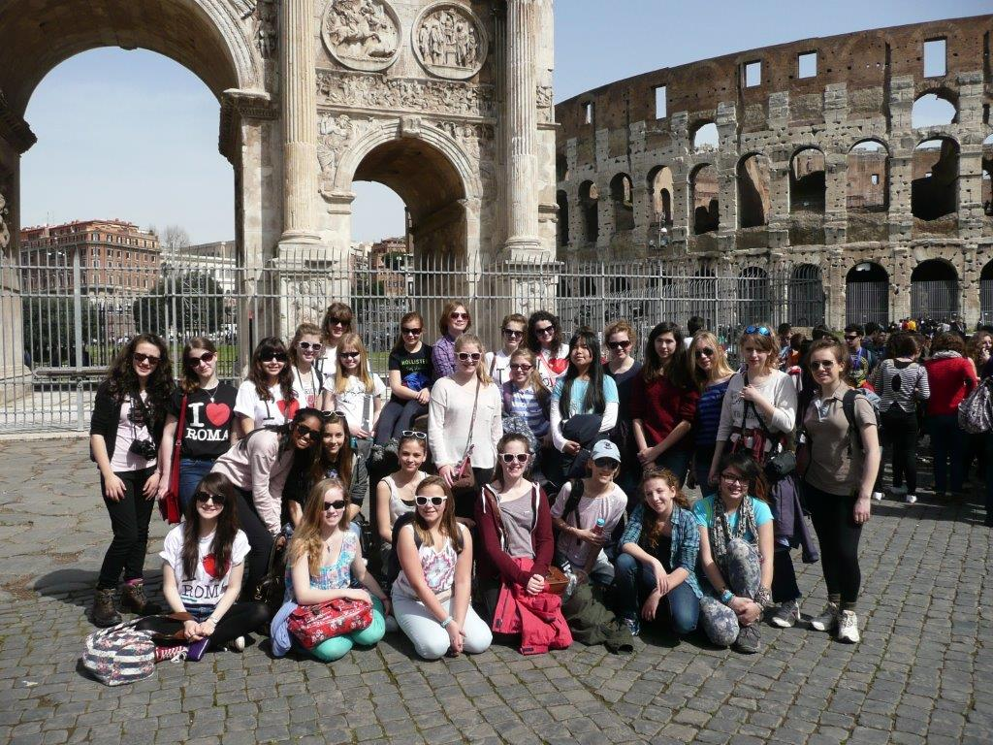

**Trip to Rome**

**The Role**

We are looking for a part-time teacher of Classics to join the team and assume the following responsibilities:

* Teach Latin up to A Level and Classics A Level.
* Marking, assessment and reporting of student progress and achievement.
* Promote the learning of Classics by being involved in initiatives such as Classics Society and external essay competitions as well as assist in leading trips.
* Contribute to the development of new specifications, schemes of work and departmental initiatives.

**REQUIREMENTS for the POSITION**

* An innovative, lively Classics teacher who will be keen to teach throughout the Senior School.
* A good Honours degree.
* Enthusiasm for the teaching of Classics.
* Use own interests and expertise to assist the department in continuing to stimulate a positive image of Classics throughout the school.
* Willingness to participate in the wider life of the school.
* Newly qualified teachers will be considered as well as experienced teachers.

**RECRUITMENT PROCESS**

Candidates are required to submit an application form with supporting letter and details of two referees. One reference should be able to comment on the teaching skills of the candidate. References will be taken up prior to interview.

Closing date for applications is **12.00pm on Tuesday 22nd April 2025.**

**Short-listed candidates will be contacted and interviews will take place on 24th/25th April.**

Candidates who have not heard from the School **by the end of April** should presume that we will not be taking their application further.

Candidates will be required to teach a lesson They will also meet with key staff and be offered a tour of the School.

All appointments are made in accordance with our equal opportunities policy and applicants should let us know of any special needs they may have.

***The School is committed to safeguarding and promoting the welfare of children and applicants must be willing to undergo child protection screening appropriate to the post, including checks with past employers and the Disclosure and Barring Service.***

