

**Mathematics Teacher – part time (0.5-0.7)**

Required for an immediate start, April or September 2025

We are looking for a dynamic, energetic, and inspirational teacher of Mathematics to join our successful Mathematics department in this high performing school. The ability to teach Mathematics up to A Level is desirable although a strong candidate with the potential and ambition to do so would also be considered.

Applications are equally welcome from early career teachers (for whom statutory induction would be provided) or from more experienced applicants.

The successful candidate will work with the department in promoting a love of Mathematics both inside and outside the classroom. A willingness to contribute to the extra-curricular activities of the School is also a requirement.

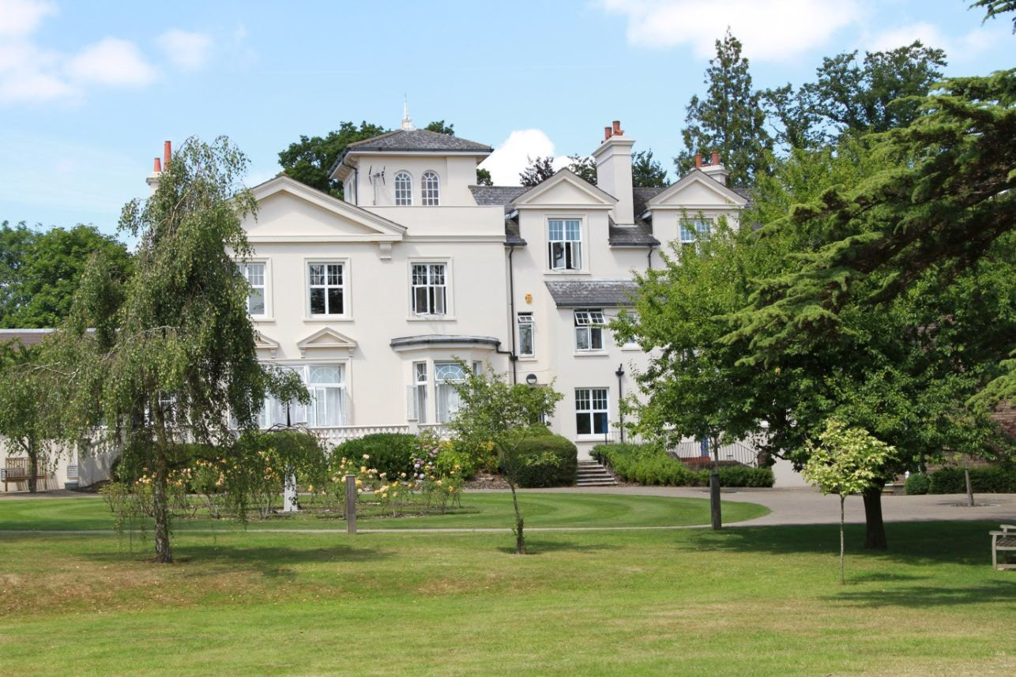

ABOUT THE SCHOOL

**Location**

The school is situated in a very pleasant thirteen-acre site in the conservation area of the town. Burgess Hill is a medium-sized town with its own theatre, orchestra, cinema and leisure centre. Burgess Hill is approximately ten miles from Brighton and Lewes, fifteen miles from Crawley and fifty miles from the centre of London. It is well served with fast roads – the M23 and M25. The school is a three-minute walk from the railway station.

**Facilities**

The School is a blend of Victorian buildings and ultra-modern facilities and there has been a steady development of the facilities.

**Curriculum**

The School offers a full range of GCSE and A Level courses in preparation for university entrance.

**Pastoral care**

Our pastoral system is designed to encourage and support the development of each individual student from the moment she arrives in school until the time she leaves. We want to provide each student with the skills and confidence to help them to make the most of their time with us, at university and beyond. Implicit in the School aims is the expectation that every teacher will accept responsibility for the development in each pupil not only of the highest academic standards, but also of the confidence and self-esteem which comes from being valued as an individual within a community.

**Co-curricular activities**

We believe that education is about giving young people the chance to be successful in as wide a range of areas as possible, and to feel a sense of pride in their achievements. Co-curricular activities give each student wonderful opportunities to explore their own talents and develop their individual skills to their full potential. The successful applicant will be expected to work effectively as part of the Mathematics team and play a full part in the wide range of co-curricular activities with which the department is involved. They will be encouraged to draw on their own interests and expertise to assist the department in continuing to promote a positive image of Mathematics throughout the school.

**Mathematics Department**

The Mathematics Department consists of five mathematicians who teach across the full range of Years.

7–13. There is a strong team spirit which helps to engender a positive and supportive atmosphere for both colleagues and students. Regular department meetings are held, and staff work together to take shared responsibility for ongoing curriculum development. INSET and internal support are provided for staff to enable them to extend their expertise into new areas.

The main aims of the Mathematics department are to promote confidence and enjoyment and to enable each girl to develop an understanding of Mathematics to her full potential. A wide range of mathematical experiences are provided and tailored to suit individual learning needs. The Department also aims to promote the perception of the importance of Mathematics both as a subject in its own right and for its relevance to the real world and to other subjects.

GCSE classes follow the IGCSE Edexcel specification. The department also offers students the option to take Edexcel GCSE Statistics, and AQA Level 2 Certificate in Further Mathematics qualifications.

Sixth Form Mathematics students follow the OCR MEI Mathematics and Further Mathematics specifications. Additional support is also offered to girls working towards MAT and STEP examinations as part of their university entry requirements.

As a department, we also offer a wide range of extra-curricular opportunities. These include wide participation in the UKMT individual Maths Challenges, where girls regularly secure a good number of bronze, silver and gold awards. We also run a club for the UKMT team challenges and compete in regional events at Junior and Senior levels. Codebreaking and Chess clubs are also on offer and annual events, such as our Autumn Maths Trail and Summer Challenge Day are important dates in our calendar. Some of our most able girls also attend Royal Institution masterclasses and Mathematical Association meetings to add to their mathematical experiences.

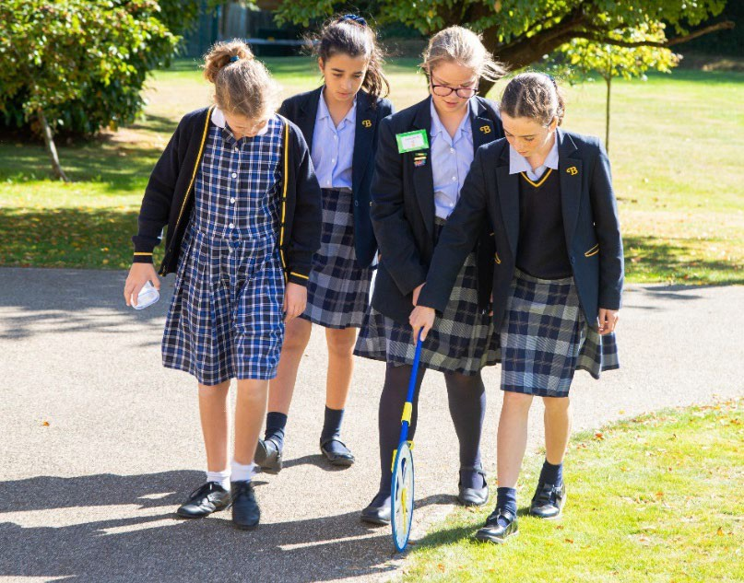

**THE ROLE**

We are looking for a part-time teacher of Mathematics to join the team and assume the following responsibilities:

• Teach Mathematics up to and including IGCSE and ideally to A Level.

• Marking, assessment and reporting of student progress and achievement.

• Promote the learning of Mathematics by being involved in initiatives such as UKMT Maths challenges and Maths Olympiad competitions and other extra-curricular activities etc.

• Contribute to the development of new schemes of work and departmental initiatives

**REQUIREMENTS FOR THE POSITION**

• An innovative, lively and enthusiastic mathematician to teach throughout the Senior School.

• Ability to meet the individual learning needs of all students.

• Ability to use a wide range of resources to enhance teaching and learning.

• Good honours degree.

• Good team player to work effectively within a high-performing Mathematics Department.

• An interest in developing the Mathematics curriculum by enriching and enhancing the teaching and learning of the subject, both inside and outside the classroom.

• Willingness to participate in the wider life of the School.

• Newly qualified teachers will be considered as well as experienced teachers.

**RECRUITMENT PROCESS**

Candidates are required to submit an application form with supporting letter and details of two referees. One reference should be able to comment on the teaching skills of the candidate. References will be taken up prior to interview.

The closing date for applications Is Friday 14th March 2025.

Short-listed candidates will be contacted by telephone and interviews will take place in the week beginning Monday 24th March 2025. Due to the need to appoint quickly, we reserve the right to offer at any stage of the process, so an early application is advisable.

Candidates who have not heard from us by the end of March should presume that we will not be taking their application further.

Candidates will be required to teach a short lesson on a topic to be decided, complete a relevant task and attend an interview. They will also meet with key staff and be offered a tour of the school.

All appointments are made in accordance with our equal opportunities policy and applicants should let us know of any special needs they may have.

The school is committed to safeguarding and promoting the welfare of children and applicants must be willing to undergo child protection screening appropriate to the post, including checks with past employers and the Disclosure & Barring Service.

